TOURS & ADVENTURES

Great place to start is:
http://www.standbycairns.com/cairns-day-tours/
Tour Reviews:
http://www.standbycairns.com/tour-reviews-by-cairns-travel-consultants/
Personal Contact: Max, Pam or Anna at Palm Coast Toursit Info Centre 07 40553433
To give you the right Tour/Adventure to fit the ADVENTURE you can’t wait to ENJOY!!

Cairns’ premier beach destination. Nestled between the Great Dividing Range and the Great Barrier Reef, Palm Cove is the ultimate location for your tropical beach side getaway. Palm Cove is only 25 minutes drive north of Cairns, highlighted by the magnificent 500+ year old Melaleuca Trees which line the entire length of the beach. Not only is there a great range of resort style shopping and a fine collection of restaurants and bars, but Palm Cove also offers all the conveniences and necessities required to make your stay as comfortable as possible. Palm Cove is an ideal stepping-stone to the Great Barrier Reef with cruise boats departing the Palm Cove Fishing Jetty daily, and is also readily accessible to the great range of daily tours and activities the region has to offer.

Reef Tours
Island Tours
Cruises
Fishing Tours
Outback Tours
Sailing Tours
Scenic Flights
Night Tours
Bike Hire

Adventure:
BTS Tours – Daintree Rainforest Day Tour
Cairns Night Zoo
Cairns Triopical Zoo Great Australian Wildlife Experience
Cairns Tropical Zoo – Breakfast Time at the Zoo
Cairns Tropical Zoo – Zootastic 5 Interact – Patting, holding, feeding
Hartleys Creek Crocodile Adventures
Cape Tribulation Day Tour
Tjapukai Aboriginal Culture
Tropic Wings Classic Kuranda Experience
Tropic Wings Cape Tribulation & Daintree Eco Experience
Value Day Tours – Karanda , Train & Skyrail
Value Day Tours – Kuranda Rail, Skyrail & Hartleys Crocodile Adventure
Kuranda Market
Value Day Tours Self Drive
Va;ie Day Tours Daintree Walkabout
Kuranda Scenic Railway
Discovery Tours Daintree & Cape Tribulation Rainforest
Discovery Tours Half Day Rainforest & Waterfall Experience
Daintree Station – Outback Station shed
Daintree Station Jungle Rumble Quad Adventures Quad Motor bikes
Daintree Station Giddy Up Rainforest Horse Rides
Cairns Zoom & Wildlife Dome

Reef Tours
Island Tours
Rainforest Tours

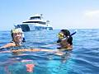 | 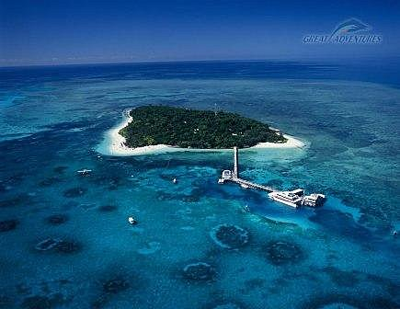 |  |  | 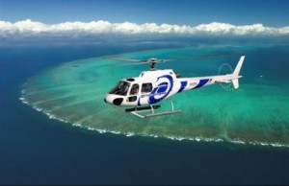
Great Barrier Reef | Island Tours |  |  | Helicopter Tours
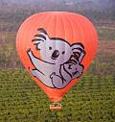 | 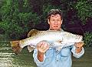 |  |  | 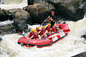
Hot Air Ballooning | Fishing Tours |  |  | White water Rafting
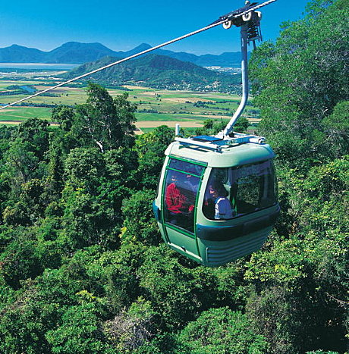 | 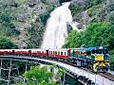 |  |  | 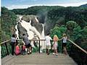
Karanda Skyrail | Karanda scenic Train |  |  | Barron Gorge view Falls
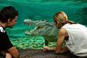 |  |  |  | 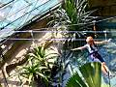
Wildlife Dome | Birds/Animals free |  |  | 20 mtr high glass dome
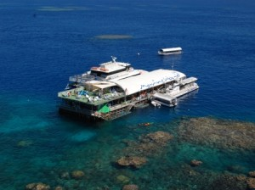 | 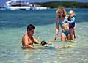 |  |  | 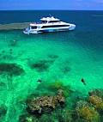
Great Barrier Reef | Family fun |  |  | Low Isles
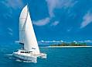 | 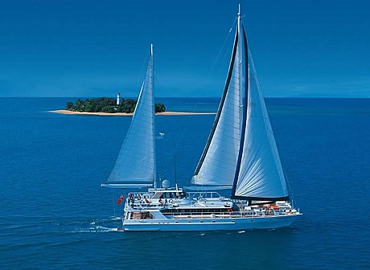 |  |  | 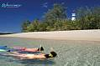
Sailing Tours | Sailing Tours |  |  | Snorkelling
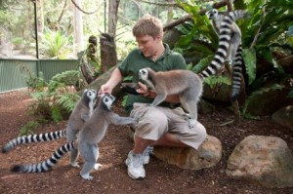 |  |  |  | 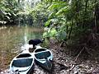
Zoo | Zoo |  |  | Daintree Forest Tour
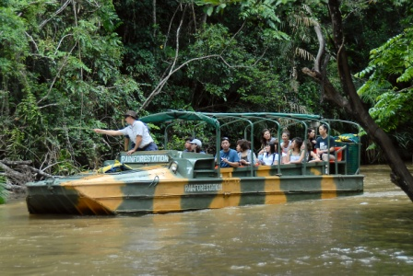 | 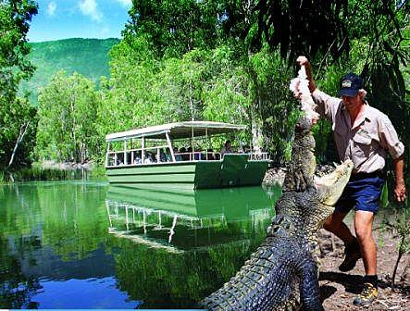 |  |  | 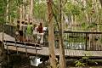
Hartleys Crocodile | Hartleys Crocodile |  |  | Hartleys Crocodile
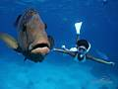 | 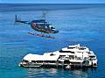 |  |  | 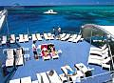
Outdoor Barrier Reef | Outdoor Barrier Reef |  |  | Outdoor Barrier Reef
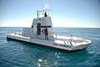 | 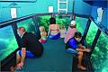 |  |  | 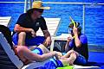
Outdoor Barrier Reef | Outdoor Barrier Reef |  |  | Outdoor Barrier Reef
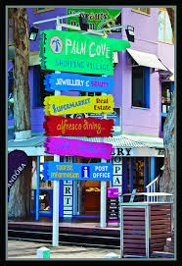 |  |  |  | 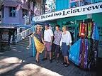
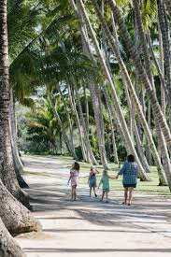 | 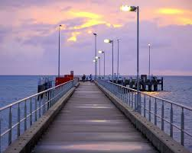 |  |  | 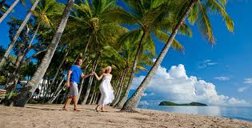
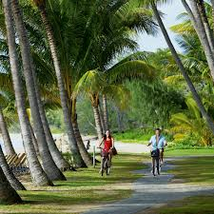 |  |  | 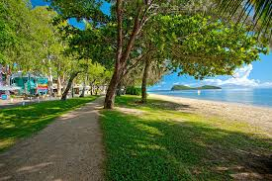
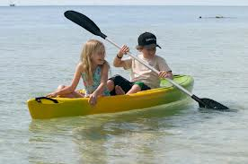 |  |  | 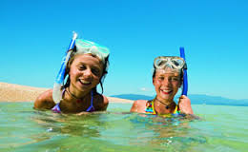
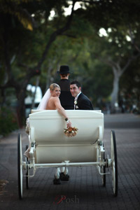 |  | 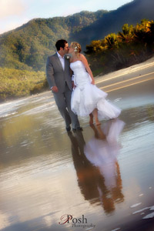 |  |  | 